**Immersive Visual Pattern Test**

1. The experiment space: You are **safe** to move around and **protected** by the instructor. You may explore the space during the training. *(Training task 1)*

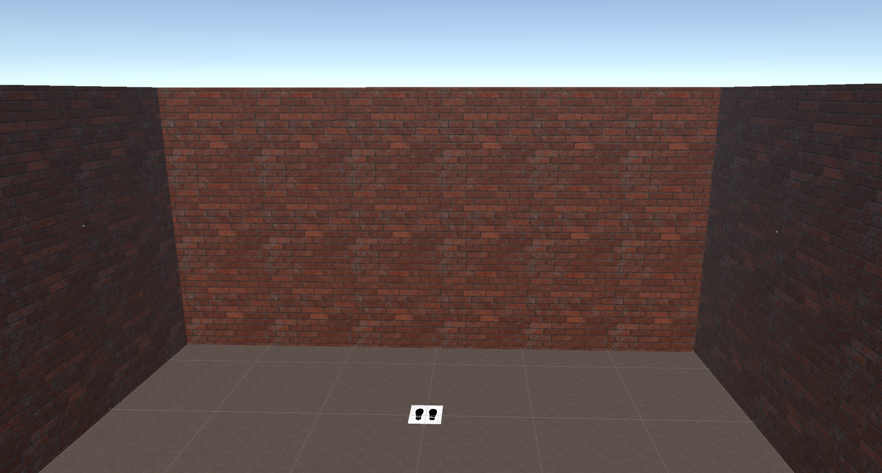

1. Visual Pattern Test
   1. Traditional Visual Pattern Test: examines short term visual memory. (see image a)
   2. Immersive Visual Pattern Test: examines visuospatial memory and kinesthetic memory. (see image b)
2. 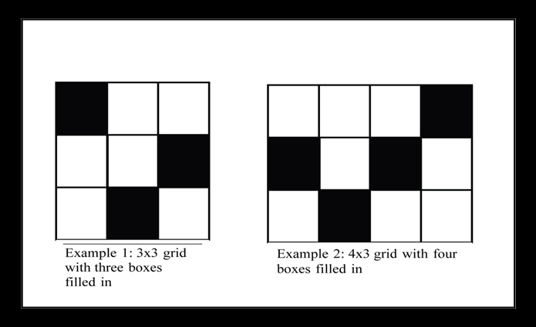
3. 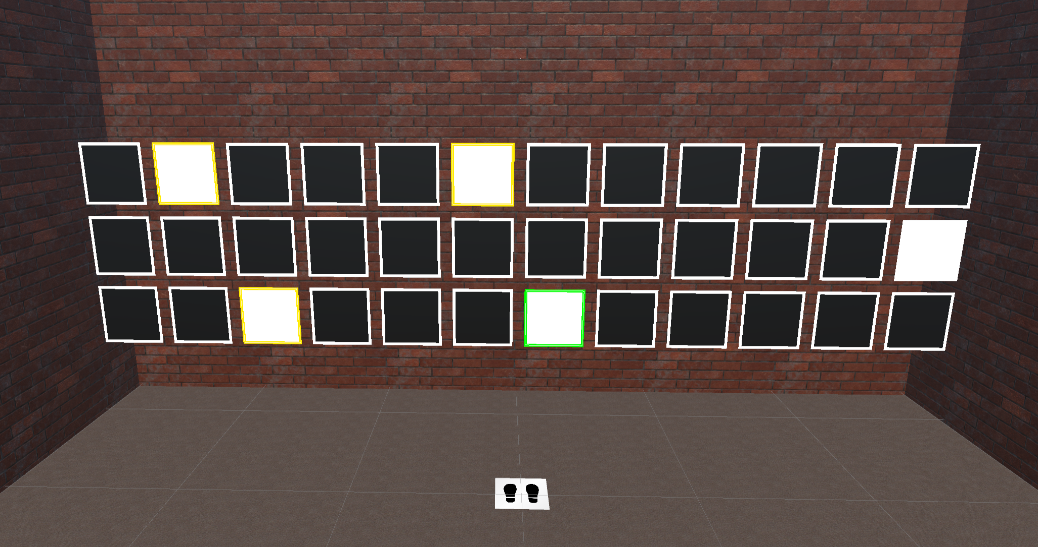
4. The experiment has three phases: **prepare**, **acquisition**, **play**, **retrieval** and **result**.
5. Prepare phase:
   1. Stand at the original position and press a button to go to the acquisition phase when you are ready.
6. Acquisition phase:
   1. There are **five** white cards out of 36 cards. You need to remember the position for all the white cards. (image b)
   2. When you see any white card, its border turns yellow. Then you need to touch it to activate your kinesthetic memory. The border of a white card will turn green when you’ve both seen and touched it. *(Training task 2)*
   3. You have a **15 seconds** timer to perform the memorisation.
   4. After you’ve seen and touched all the white cards, you will be navigated to the play phase.
7. Play phase:
   1. You will play a number touching game in 15 seconds by default. You need to use the controller to touch the number card as per instruction. Penalties will be adding 3 more seconds to the play phase when you touched the wrong card or no interaction for more than 3 seconds. *(Training task 3)*
8. Retrieval phase:
   1. You need to select (touch the card) 5 cards as you remembered. *(Training task 4)*
   2. There is no time limit for this phase.
   3. You cannot undo what you’ve selected.
   4. Press a button to confirm your answer.
9. Result phase:
   1. You will see the result on the wall, eg. Result: 4 / 5.
   2. Press a button to go to the prepare phase for the next trial.
10. Note: when you see the image below, go back to the original position. *(Training task 5)*

